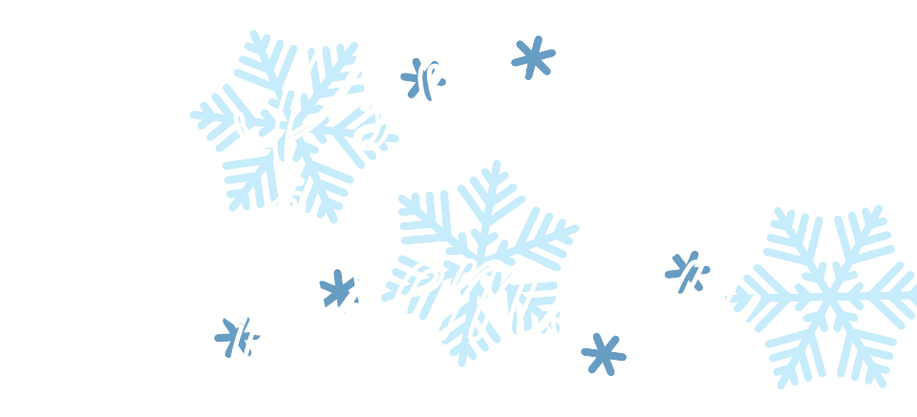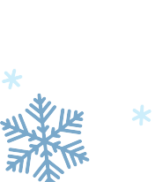

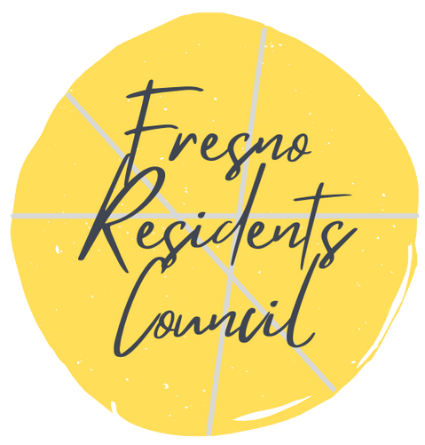 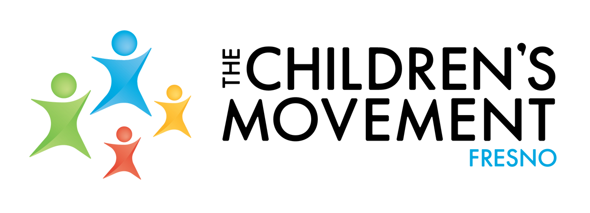

Pawg Sab Laj N tawm Pej Xeem Ntawm Nroog Fresno

COV ME NYUAM YAUS KEV TXAV MUS LOS NTAWM NROOG . FRESNO

Koom nrog peb ntawm Fresno TCM

Teeb meem

Kev sib dhos

# Hnub Saturday, Lub kaum ob hli hnub tim 1 1 thaum 1 0 am- 1 pm ntawm Txoj Kev Elite

4 1 05 W F i g Garden Dr i ve, F resno, CA 93722

Thaum noj su Yuav tsum tau sau npe .

Raws li tus tswv cuab ntawm pawg sab laj ntawm pej leem hauv nroog fresno, peb tos ntsoov yuav ntsib koj ntawm qhov kev tshwm sim tshwj xeeb rau hnub Saturday, Lub kaum ob hli hnub tim 11 thaum 1 0 am- 1 pm

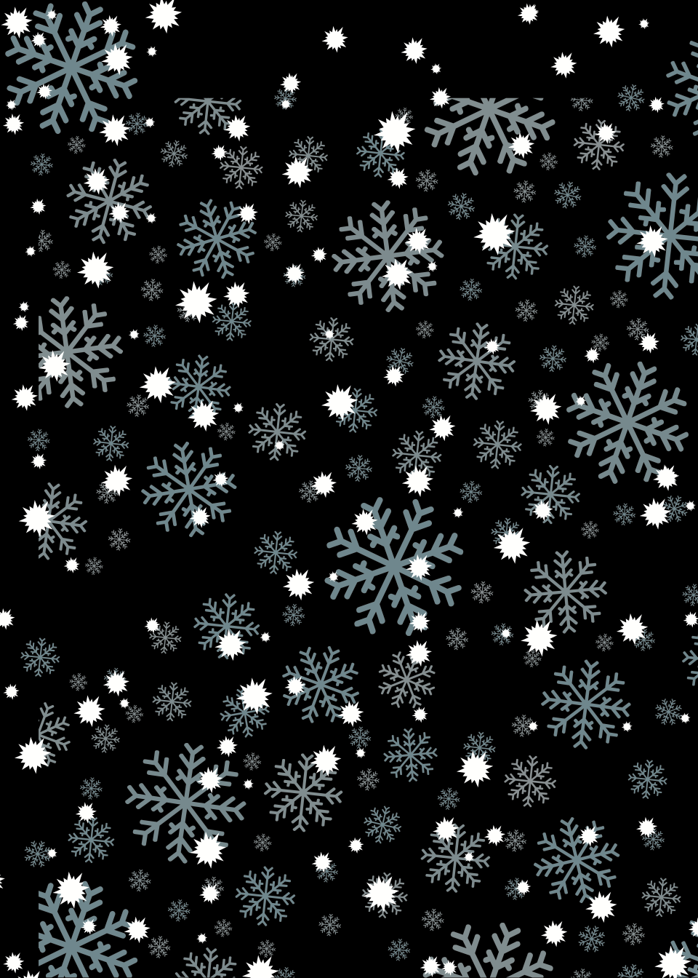

Peb yuav koom ua kev zoo siab rau peb lub hom phiaj uas tiav thiab txiav txim siab rau qhov tseem ceeb ntawm kauj ruam yam tom ntej uas peb yuav ua raws li pawg sab laj.

NTAWM NO RSVP

[RSVP H ERE](https://www.eventbrite.com/e/187387269367)

Ntaub npog qhov ncauj thiab kev ntsuas kub yuav tsum muaj thaum tuaj txog. Ntaub npog qhov ncauj yuav tsum muaj thaum tsis tau zaum.

Me nyuam yaus. kev thauj mus los. thiab kev txhais lus yuav muaj yog tias thov thaum sau npe.

**RSVP YUAV TSUM LOS NTAWM LUB KAUM IB HLI HNUB TIM 27, 2021**